**Experiment No : 07**

**Experiment Name :** Implementation of FIFO page replacement algorithm .

**Objective:**

FIFO stands for First In First Out Algorithm..We know about the algorithm and Implement it in C/C++ programming Language .

**Source Code :**

#include<stdio.h>

int main()

{

int i,j,n,a[50],frame[10],no,k,avail,count=0;

printf("\n ENTER THE NUMBER OF PAGES:\n");

scanf("%d",&n);

printf("\n ENTER THE PAGE NUMBER :\n");

for(i=1; i<=n; i++)

scanf("%d",&a[i]);

printf("\n ENTER THE NUMBER OF FRAMES :");

scanf("%d",&no);

for(i=0; i<no; i++)

frame[i]= -1;

j=0;

printf("\tref string\t page frames\n");

for(i=1; i<=n; i++)

{

printf("%d\t\t",a[i]);

avail=0;

for(k=0; k<no; k++)

if(frame[k]==a[i])

avail=1;

if(avail==0)

{

frame[j]=a[i];

j=(j+1)%no;

count++;

for(k=0; k<no; k++)

printf("%d\t",frame[k]);

}

printf("\n");

}

printf("Page Fault Is %d",count);

return 0;

}

**Output :**

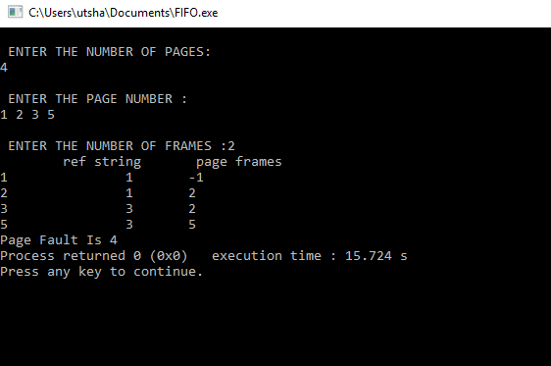

**Conclusion :**

FIFO is the simplest scheduling algorithm. FIFO simply queues processes in the order that they arrive in the ready queue.So it is Very Important Algorithm to know and execute in Further . In operating systems that use paging for memory management, page replacement algorithm are needed to decide which page needed to be replaced when new page comes in. Whenever a new page is referred and not present in memory, page fault occurs and Operating System replaces one of the existing pages with newly needed page. Different page replacement algorithms suggest different ways to decide which page to replace. The target for all algorithms is to reduce number of page faults.

.